SQL ASSIGNMENT-1
- Describe the employee table.
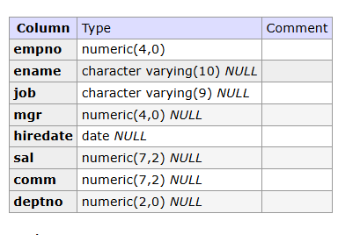

- Query the employee table
COMMAND - SELECT * FROM emp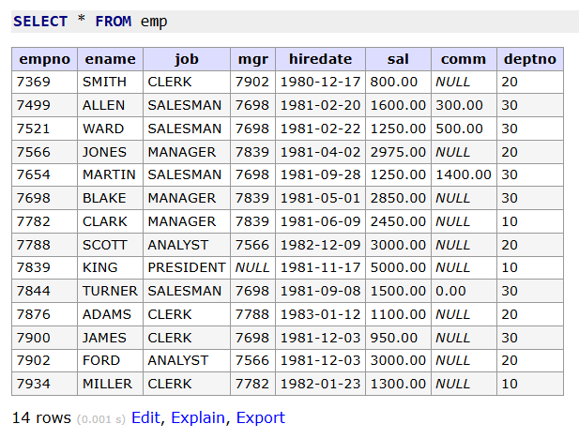
- List employee number and the name of the employee
COMMAND - SELECT empno,ename from emp ;
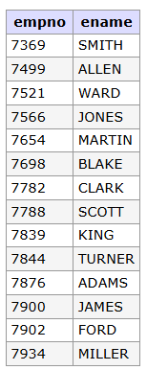
- List employee number and name of employee with the headings as NUMBER and NAME.
COMMAND – SELECT empno AS "NUMBER" ,ename AS "NAME" FROM emp ;

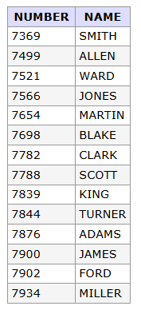
- List the employees working in department 20
COMMAND - SELECT ename FROM emp WHERE deptno=20
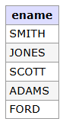
- List the employees of department 10 and 20
COMMAND - SELECT ename FROM emp WHERE deptno BETWEEN 10 and 20;
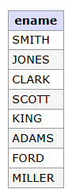

- List the employees who joined after 01/01/82.
COMMAND - SELECT ename FROM emp WHERE hiredate > '1982-01-01';
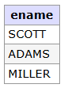
- List the employees of dept 10 who joined after 01/01/82.

- List the salary of all the employees.
COMMAND - SELECT sal FROM emp ;

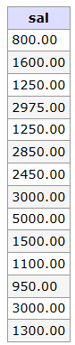
- List the employees who do not receive commission.
COMMAND - SELECT ename FROM emp WHERE comm IS NULL OR comm=0;
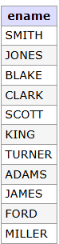
- List the employees who receive 0 commissioN
COMMAND – SELECT ename FROM emp WHERE comm=0;
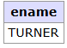
- Select the employees in department 30
COMMAND - SELECT ename FROM emp WHERE deptno=30;
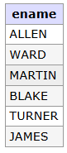

13 List the names, numbers and the names of employees of all departments with department number greater than or equal to 20.
COMMAND - SELECT ename,empno FROM emp WHERE deptno>=20;
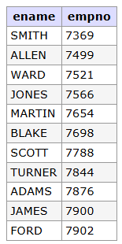

- Find the employees whose commission is greater than 60 percent of their salary.
COMMANDS - SELECT ename FROM emp WHERE comm>0.6*sal;
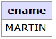

15. List the name, job and salary of all employees in department 20 who earn more than Rs. 2000.
COMMANDS - SELECT ename,job,sal FROM emp WHERE deptno=30 and sal>2000;
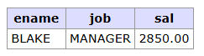

16. Find all salesmen in department 30 whose salary is greater than or equal to Rs. 1500.
Commands - SELECT ename FROM emp WHERE job='SALESMAN' and deptno=30 and sal>=1500;
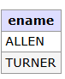

17. Find all employees whose job is either manager or president.
Commands - SELECT ename FROM emp WHERE job='MANAGERS' or job = 'PRESIDENT';

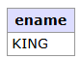

18. Find the details of managers and clerks in department 10.
COMMANDS - SELECT * FROM emp WHERE job='MANAGER'AND deptno=10 or job = 'CLERK' AND deptno=10;
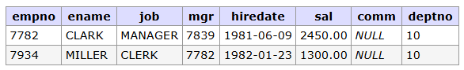

19. Find details of all managers in any department and all clerks in department 10.
COMMANDS - SELECT * FROM emp WHERE job='MANAGER' or (job='CLERK'and deptno=10);
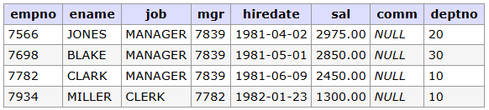

20. Find details of all managers in department 10 and all clerks in department 20.
COMMANDS - SELECT * FROM emp WHERE (job='MANAGER'and deptno=10) or (job='CLERK'and deptno=20);
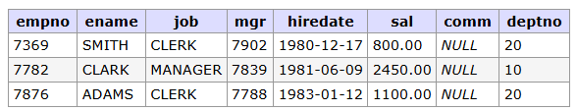

21. Find the details of all the managers in department 10 all clerks in department 20 and all employees who are neither managers nor clerk and whose salary is greater than or equal to Rs. 2000.
COMMANDS - SELECT * FROM emp WHERE (job='MANAGER'and deptno=10) or (job='CLERK'and deptno=20) or job not in ('CLERK' , 'MANAGER') ;
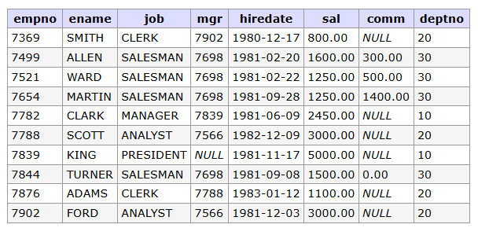

22. List salaries of all employees in descending order.
COMMANDS - SELECT sal FROM emp ORDER BY sal DESC
